St Andrew, Orford with Longford

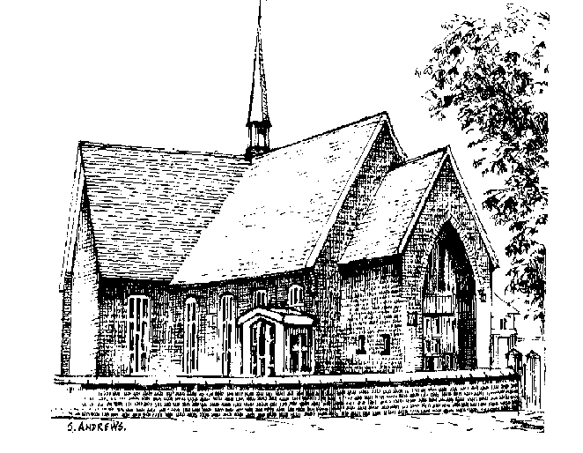

In loving memory of

Joyce Jenkinson

Friday 1st November 2013

Order of Service

Introduction

All: Merciful Father, hear our prayers and comfort us; renew our trust in your Son, whom you raised from the dead; strengthen our faith that all who have died in the love of Christ will share in his resurrection; who lives and reigns with you, in the unity of the Holy Spirit, one God, now and for ever. Amen

Hymn “Praise, my soul, the King of heaven”

Praise, my soul, the King of heaven,
to his feet thy tribute bring;
ransomed, healed, restored, forgiven,
who like me his praise should sing?
Alleluia, Alleluia,
praise the everlasting King.

Praise him for his grace and favour
to our fathers in distress;
praise him still the same as ever,
slow to chide and swift to bless:
Alleluia, Alleluia,
glorious in his faithfulness.

Father-like, he tends and spares us,
well our feeble frame he knows;
in his hands he gently bears us,
rescues us from all our foes:
Alleluia, Alleluia,
widely as his mercy flows.

Angels, help us to adore him;
ye behold him face to face;
sun and moon, bow down before him,
dwellers all in time and space:
Alleluia, Alleluia,
praise with us the God of grace.

Poem by Amy (Joyce’s great-granddaughter)

The Scriptural Reading: John 14. 1-6

The Eulogy (Tribute) prepared by Joyce’s family

The Prayers and Lord’s Prayer:

Each section concludes:
Lord, in your mercy
All: hear our prayer.

After the final section:
God of mercy, entrusting into your hands all that you have made and rejoicing in our communion with all your faithful people, we make our prayers through Jesus Christ our Saviour. Amen.

All: Our Father, who art in heaven, hallowed be thy name; thy kingdom come; thy will be done; on earth as it is in heaven. Give us this day our daily bread. And forgive us our trespasses, as we forgive those who trespass against us. And lead us not into temptation; but deliver us from evil. For thine is the kingdom, the power and the glory, for ever and ever. Amen.

Hymn: “Immortal, invisible, God only wise”

Immortal, invisible, God only wise,
in light inaccessible hid from our eyes,
most blessed, most glorious, the Ancient of Days,
almighty, victorious, they great name we raise.

Unresting, unhasting, and silent as light,
nor wanting, nor wasting, thou rulest in might;
thy justice like mountains high soaring above
thy clouds which are fountains of goodness and love.

To all life thou givest, to both great and small;
in all life thou livest, the true life of all;
we blossom and flourish as leaves on the tree,
and wither and perish; but naught changeth thee.

Great Father of glory, pure Father of light,
thine angels adore thee, all veiling their sight;
all laud we would render: O help us to see
‘tis only the splendour of light hideth thee.

The Commendation: (please remain standing)

Priest: Let us commend Joyce to the mercy of God our Maker and Redeemer.

With this water we call to mind Joyce’s baptism. As Christ went through the deep waters of death for us, so may he bring us to the fullness of resurrection life with Joyce and all the redeemed.

God our creator and redeemer, by your power Christ conquered death and entered into glory. Confident of his victory and claiming his promises, we entrust Joyce to your mercy in the name of Jesus our Lord, who died and is alive and reigns with you, now and for ever. Amen

All: Heavenly Father, in your Son Jesus Christ you have given us a true faith and a sure hope. Strengthen this faith and hope in us all our days, that we may live as those who believe in the communion of saints, the forgiveness of sins and the resurrection to eternal life; through Jesus Christ our Lord. Amen.

Priest: May God, in his infinite love and mercy, bring the whole Church, living and departed in the Lord Jesus, to a joyful resurrection, and the fulfilment of his eternal kingdom. Amen.

                        

